Project Spam Email Detector

Problem Statement:

Email spam wastes time, increases cybersecurity risks, and can expose users to phishing attacks and malware. Traditional rule-based spam filters struggle to keep up with evolving spam techniques.
This following project and report will investigate whether the use of machine learning can automatically classify email as spam or legitimate based on the text content and format.

Aims:
The aim of this project is to create a product that can efficiently detect if an email is spam or legitimate based on the text content that is also easy to use.

Targets:
One of my targets is to make people more vigilant and wary when it comes to coming across spam emails and having the intuition to spot a legitimate email from a fake one.
Another one of my targets is to maintain a 80% success rate in terms of successfully detecting if the text from an email is actually spam or not.

Objectives:
- Build an easy-to-use product with python, HTML, and various Machine learning features and techniques
- Close the barrier in terms of people acknowledging the difference between a legitimate and a spam email.
- Use a dataset to learn text classification so that it can be used for my model to ensure that when detecting the text content that it is accurate.
- Improve my skills within machine learning and Python in general
- Prepare myself for my Masters course where I will have to do an entirely different project that could potentially be ML/AI related.

Resources:
To solve the problem outlined early in the problem statement section. The following resources that I will be implementing into this project in order to achieve my goal includes:
- Python
- HTML
- Text Processing
- Feature Extraction
- TF-IDF
- Naïve Bayes
- Logistic Regression
- Random Forest
- Model Evaluation
- Flask
- Git
What is spam?
Spam is the use of electronic messaging system to send bulk messages that are unsolicited. This can be in the form of SMS messages, and emails.

How global email traffic is dominated by spam emails;
Spam accounted for 47.27% of global email traffic in 2024, which was an increase by 1.27% from the previous year. This shows that even with the counter-measures put in place to help decrease spam emails is not productive as they have become more and more prominent within email traffic. There are a variety of categories that can be classed as spam emails. This includes phishing & malicious content, commercial spam, scams and hoaxes, tech support scams and many more.

Demographic that is affected the most:
It is reported that the most targeted sector in spam emails are professional services (18%) and shortly followed by manufacturing and retail/wholesale with 18% and 9% respectively. (Ellis, 2023). Delivery services were the most common subject of spam messages with over 1.1 billion scam texts relating to this topic. This is unsurprising as a vast majority of people uses these delivery services to have the items be delivered so the use of creating identical messages with the same format and structure that these various delivery services use can easily deceive people into entering their personal information and therefore have it taken and be used maliciously.
The demographic that receives the most spam messages/emails/calls are people aged 65 and over, while 18-34 year olds receive the lowest. (Ellis, 2023). There is a direct correlation with this as it shows that elderly people are not entirely “internet savvy” and are more prone to being deceived into clicking malicious links and having their personal information seized. The reason for this is that they have not be trained and taught extensively in how to prevent this and take action plus the era that they were brought into were not this advanced when it comes to technology, which leaves them to learn about this as they got older. Whereas with younger people, we were taught how to deal with spam emails, and malicious attacks so we would not be deceived when receiving one.
This shows that with the product I will make, I have to be able to make it user-friendly for all demographics to be able to bridge that gap of learning spam-based literacy so that it can prevent further attacks.

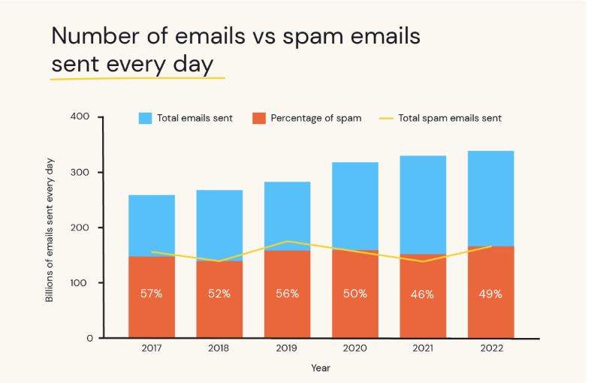
Figure 1 containing number of emails vs spam emails sent every day (Ellis, 2023)

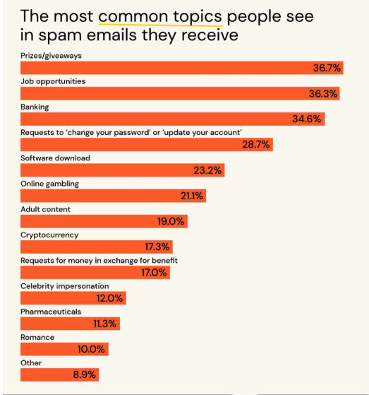
Figure 2 the most common topics people see in spam emails they receive (Ellis, 2023)

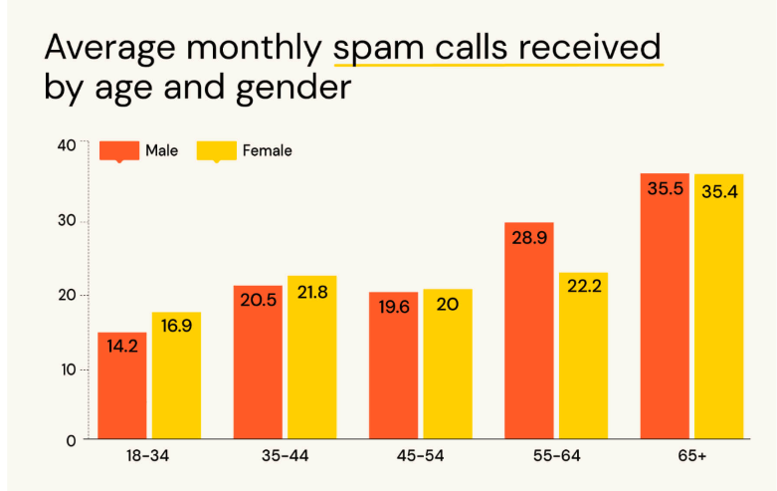
Figure 3 Average monthly spam call received by age and gender (Ellis, 2023)

Obtaining and loading the dataset:
Next, I am going to obtain and load a dataset from Kaggle that contains various Spam and Ham (Ham meaning legitimate emails) to analyse it and to learn its text classification. This will help the accuracy of the detector to ensure it is detector the right content as spam.
The dataset I used: https://www.kaggle.com/datasets/ashfakyeafi/spam-email-classification
I then proceeded to load the dataset into python using the kagglehub library and loading it as a csv so I can view it on excel and manipulate to for analysis.
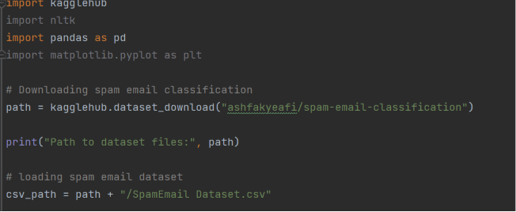
Figure 4 loading spam email dataset into my python file
Count of “spam” & “ham” emails:
Next, I wanted to explore the various features that this dataset has such as the count of how many email are spam and ham. In this case there are 4825 “ham” legitimate emails and 747 spam emails within the dataset.
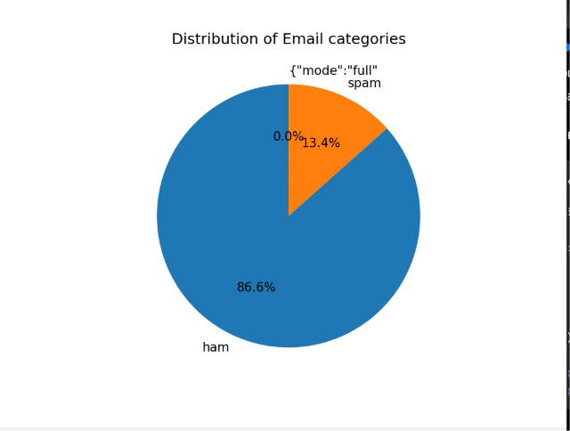
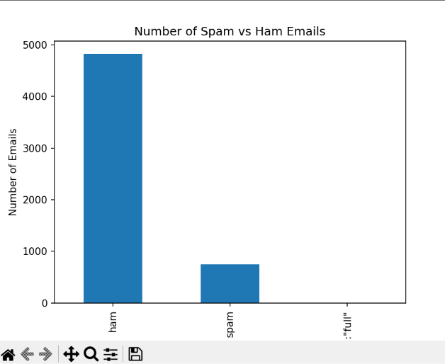
Figure 7 Pie chart showcasing the distribution of email types
Figure 5 Bar chart showcasing the number of spam and ham emails

Structure of Dataset:
In terms of the structure of the dataset there are two columns, with one column being the category so if the message is either “ham” or “spam” and the second column is the Message column. This column contains the text content of the ham or spam message.
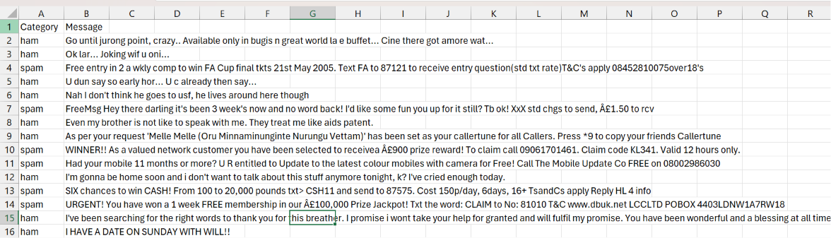
Figure 8 structure of the spam email dataset
Calculating average email length:
When it comes to calculating the average length of a spam or ham email, it shows that spam emails has an average email length of 137.9 with length being used to measure that amount of characters within an email. For ham emails, it has an average character length of 71.4 characters. This shows that spam email usually include more characters in this specific dataset. It also shows us that when detecting if an email is spam or legitimate, taking note of the amount of characters used can give us an indication if such email is real or not. I calculated this on Python using the pandas library to make a new column within the dataset to display this.

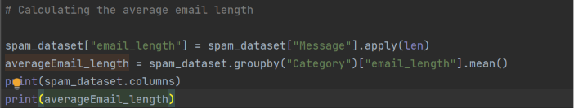
Figure 9 Python code used to calculate average email length
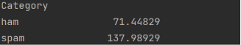
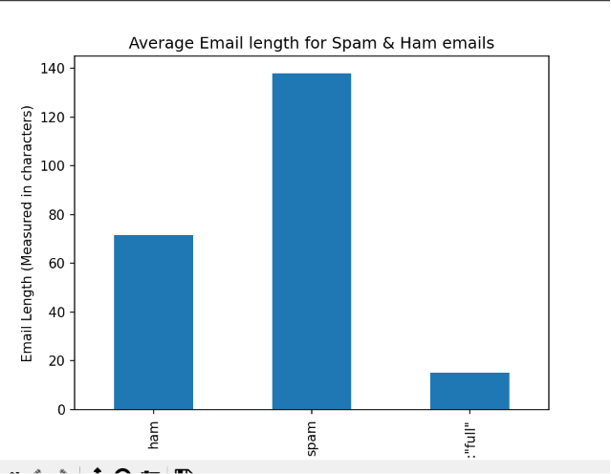
Figure 11 python calculating average length output
Figure 10 bar chart representing average email length

Most frequently used Spam and Ham words:
Next I am going to find out the most frequently used words used in both Spam and Ham emails. This part of the data analysis will help me understand what makes a spam email differentiate from a legitimate one. It will also help me understand what are the common words that can help contribute to the detector to allow it to be more accurate and efficient when detecting text content from emails.
During this section there was an issue I had to overcome. When calculating the most frequent words it was working originally however, the frequent words that were appearing within the chart consisted of words that can be considered to be stop words.
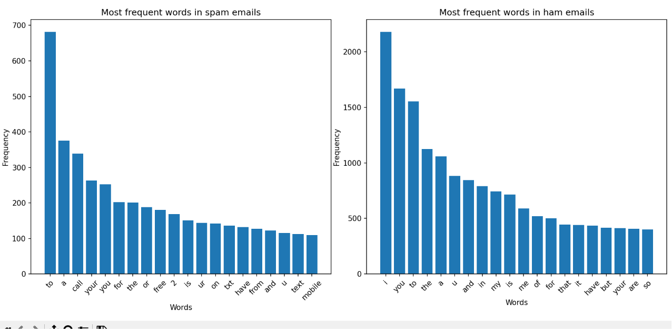
Figure 12 Most frequent words in ham and spam emails before editing to remove stop words
As you can see, the chart has been dominated by words such as "the”, “to”, “and”, “a” etc..
So to fix this, I imported another library called NLTK which is used for building Python programs to work with human language data it provides it users with a variety of tools used to analyse, clean and structure raw human language data. In this specific use case, it is being used to eliminate stop words being involved in the most frequent words chart as it will improve the accuracy and discrepancy of the chart and eventually for the detector being built.

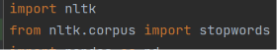
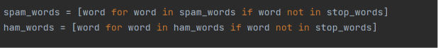
Figure 13 Importing nltk module for stop words
Figure 14 stop words being implemented in the code

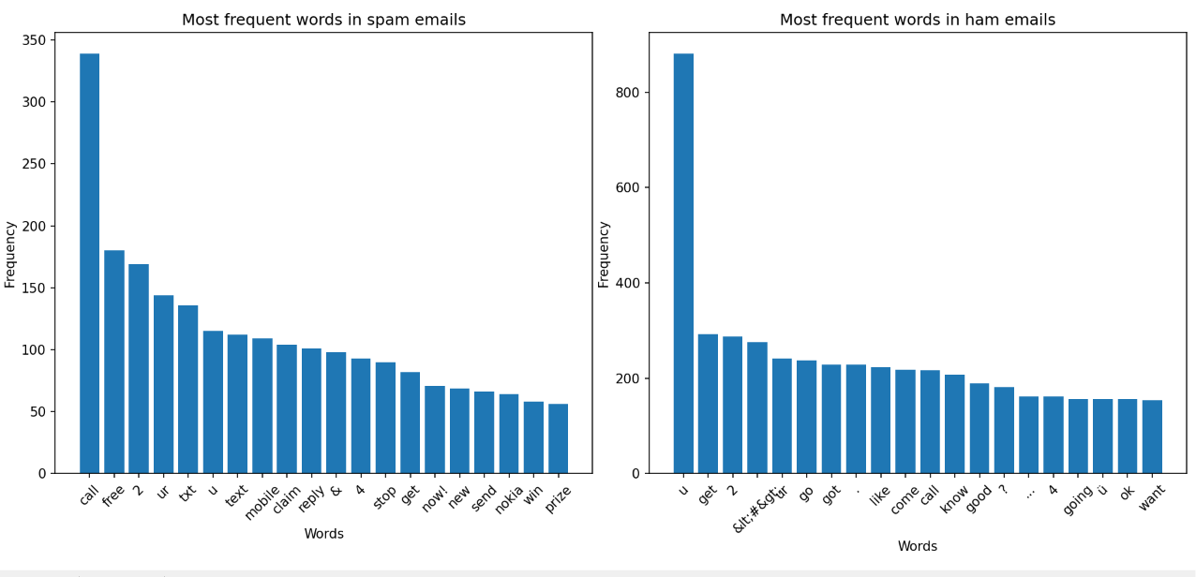
These two figures shown above displays how the nltk module was implemented within my code to remove stop words being counted towards the count of the most frequent words. For example, what the code shown in figure 14 does is that it finds every word being used in both ham and spam and keep said word if it is not a common English word (stop word). To determine what a stop word is so that it is accurate in detecting and removing them, the NLTK stop words module has a list which contains a variety of stop words. This helps as if that specific word in the list matches the one in “ham_words” or “spam_words”, it will be removed.
Figure 15 chart of most frequent words after removing stop words

As you can see, after the removing the stop words, it makes the count more accurate and can see a clear distinction between the type of words more likely to be featured in a spam and ham email.
For spam emails, it includes words such as “call”, “prize”, “win”, and claim which can be interpreted as spam emails that can be classified as fake prize giveaway and lottery emails. With these type of emails, it includes text content that includes false promises of massive wealth to trick the user into giving away their money and data. This backs up figure 2 with the most common topics people see in spam emails with prize & giveaways topping the chart.
When looking at the frequent words seen in ham emails, the type of language seen is more colloquial and informal with words including “u”, “good”, “like” etc… Words like these are great indicators to tell if an email is legitimate as spam emails are more likely to copy the text content of emails from companies and organisations to make it look as realistic as possible whereas with ham emails, it is most likely the person you are emailing is someone you know personally such as a friend, colleague so there would be no need to use such professional language.

Punctuation Analysis:
Punctuation analysis is important for this report as spam emails often use punctuation differently from legitimate emails. It is common practice within spam emails to use excessive punctuation to garner attention, create urgency, and encourage the recipient to take action immediately. For example, “WINNER!! As a valued network customer you have been selected to receivea Â£900 prize reward! To claim call 09061701461. Claim code KL341. Valid 12 hours only.” This is an example of a spam email within the dataset.
This analysis is also important as it can be used to see whether punctuation can help distinguish spam from ham. If spam emails contain more exclamation marks, question marks, and symbols on a consistent basis, these characteristics will become useful features for my model and classifier.
First I did a count of the number of exclamation marks (!).
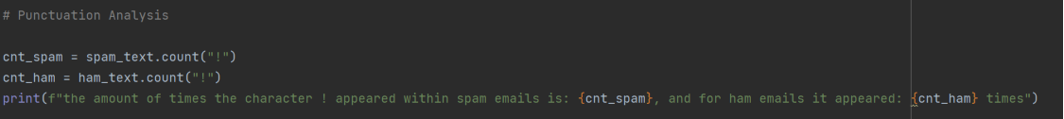
Figure 16 code displaying count of exclamation marks within spam and ham emails

Figure 17 output of code displayed in figure 16
As you can see, the amount of times a punctuation mark appeared in spam email was 546 and for a ham email it was 852. This was inaccurate and not correlating to the statement I made earlier. This is because there are 4825 ham emails as opposed to 747 spam emails making it unfair to analyse the amount of exclamation marks via a total count. So to improve the consistency of my analysis I calculated the average amount of exclamation marks per email instead to display a fairer outcome.

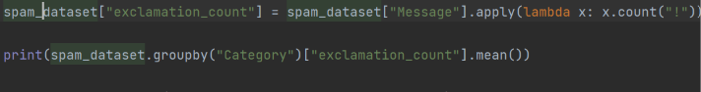
Figure 18 code to produce average amount of exclamation marks within email

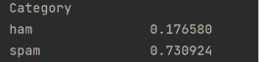
Figure 19 output displaying average number of exclamation marks per email

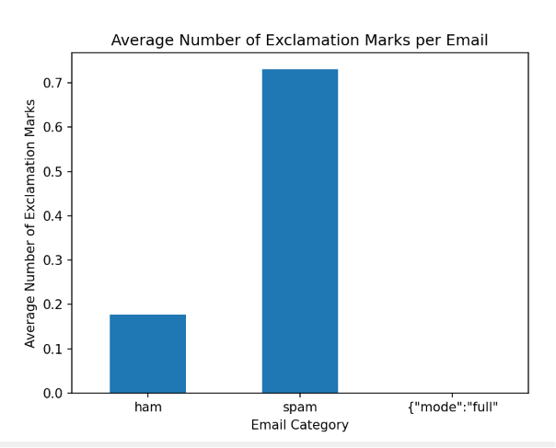
Figure 20 average number of exclamation marks per email
By calculating the average number of exclamation marks per email, it now shows that exclamation marks within spam emails are more prevalent than in legitimate emails. This is a good indicator to see whether an email is legitimate or not.
Next was the count of question marks:
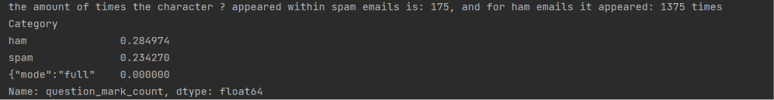
Figure 21 Output of question mark analysis code

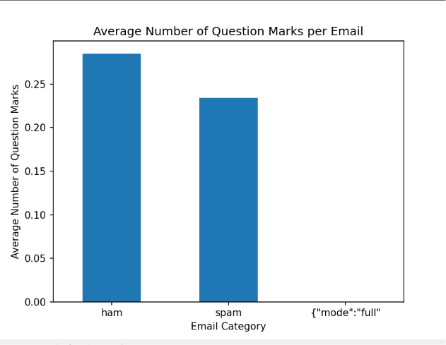
Figure 22 Chart showcasing average no of question marks per spam and ham email

With the output shown here, it displays how ham emails have a higher percentage of question marks (?) per email with a total of 1375 and it having an average of 0.28 whereas with spam emails, it has a total of 175 and an average of 0.23.
What this can entail is that within legitimate emails, they are more likely to be asking questions and having genuine conversation with the recipient. With spam emails on the other hand, the way question marks would generally be used is in a way to convey the user that such thing that they are promoting is too good to be true.
Another way they are used within spam emails is in a more “direct” manner making a direct statement as such. For example, “Want 2 get laid tonight? Want real Dogging locations sent direct 2 ur mob? Join the UK's largest Dogging Network bt Txting GRAVEL to 69888! Nt. ec2a. 31p.msg@150p.”
To conclude, using question marks as an indicator to see if the text content within an email is legitimate or otherwise is not an efficient way of doing so as question marks are very commonly used in normal conversation.

Number & Symbol analysis:

This part of the analysis is something that will directly help and impact the machine learning model and detector that will be constructed later on.
The reasoning and purpose of performing analysis on numbers and symbols is to investigate whether spam emails have distinctive numerical and symbolic patterns that differs in legitimate emails. Spam emails are designed to grab the attention of users and convince them to take immediate action for example:
“Sunshine Quiz Wkly Q! Win a top Sony DVD player if u know which country the Algarve is in? Txt ansr to 82277. Â£1.50 SP:Tyrone”, “You are a winner U have been specially selected 2 receive Â£1000 cash or a 4* holiday (flights inc) speak to a live operator 2 claim 0871277810810”
With these emails you can see how these emails attempt to sway your attentiveness to take action. This can be with the over exaggeration of exclamation marks and capital letters, and the numbers and symbols being utilised. The absurd amounts of money supposedly being rewarded to you can make the user have the intuition to think such sum cannot be awarded to them however, with the structure of the text content being constructed, how legitimate it seems to be is why the end users potentially get trapped into these professional scams.
Therefore reviewing the patterns that these numbers and symbols have within these spam emails is important.
Number Analysis:
How many numbers does each email contain?
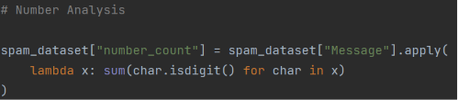
Figure 23 code displaying the count of how many digits appear
What this does is that I am selecting the column that contains the text content of emails which, in this case it is “Message”. Then this specific operation I am computing should be performed on every email so to do that I included .apply(). This enables the function to automatically loop through every row for both spam and ham emails. Next is to look at each character in the email which is done with char.isdigit(). With this, Python checks for each character and labels each non digitised character as false and true for each numerical digit.
Now it is time to calculate the average:
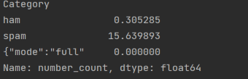
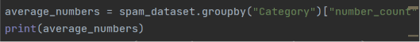
Figure 25 output displaying average amount of numbers within a spam and ham email
Figure 24 code to show the average numbers in spam and ham emails

What this shows is that spam emails contain, on average, more numerical digits than legitimate emails and that there is a direct correlation between a high usage of digits within an email and it potentially being classified as spam.
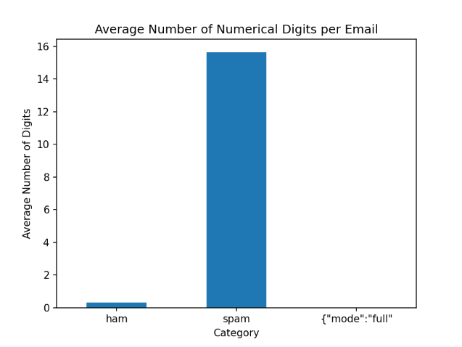
Figure 26 chart displaying the average number of numerical digitised character per email

To showcase what this data I calculated is trying to tell us, I also plotted a box plot as that goes into depth into the distribution and variability within each category. It also tells us the median value, how spread out the data is, and what category of emails has more variation in this case the amount of digits being used.
Box plots will also help justify why this part of the analysis is useful for distinguishing spam from legitimate emails.
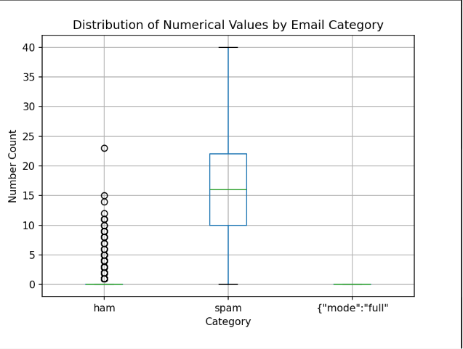
Figure 27 box plot to show the distribution of numerical value by spam and ham emails

What this plot shows is that ham emails has almost all values at 0 with some outliers with the highest one going all the way up to 23, meaning that one of the ham emails had 23 digits within it. With spam, the box sits higher with the median around 16, the middle 50% of values between 10 and 22, a lowest count being 0, and a max of 40. This shows that spam emails tend to be packed with numbers within its emails due to the content of it including prices, phone numbers, “you won £xxxx”, etc.

Do spam emails contain longer numerical sequences than legitimate emails?

Another example of number analysis that can be performed to further differentiate spam and ham emails, to remain consistent in the analysis in terms of that a conclusion cannot be made with one test, and to improve the accuracy of the model to be made is researching if spam emails contain longer numerical sequences than legitimate emails.
This is important as by just counting digits and calculating the average numerical digits per email only tells us how many numbers exist. Measuring the length of each number tells us what kind of numbers are being used. For example with an email including this passage: “Win £5000 today!” What it shows is that the numbers found is 5000 and the length of the longest number within the email is 4. Another example: “Call 08001234567 now!” The numbers found within this spam email is 08001234567 and its longest length being 11.
Spam often contains prize amounts, phone numbers, account numbers, voucher codes, tracking numbers and these types of numbers tend to have a longer sequence of digits than the simple dates, times, and occasional long number found in ham emails.
To do this first another module had to be imported, which in this case is regular Expressions (import re). this is because regular Expressions (regex) enables us to search for patterns in text. This helps as instead of searching for one exact number, we want to find every sequence of digits.

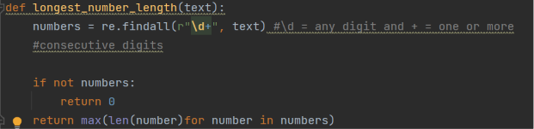
Figure 28 function which operates to find the longest number length with email
What this function does is that it finds all the numbers using regex built in function re.findall and also using \d which mean all digits 0-9 and + which mean one or more consecutive digits. Then what I implemented helps when encountering emails that do not have any numbers within them using “if not numbers: return 0” 0 in this case means no numerical sequence. The next step is to find the longest number which was done with the last return statement.
Figure 29 applying the function shown on figure 28 to every email and comparing the two emails types
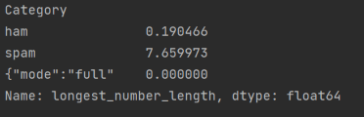
Figure 30 output of the longest_number_length and comparison code block
What this shows is that there are an average number sequence length of 7.65 within spam emails and only 0.19 within ham emails. What can be gathered from this data is that emails with longer numerical sequences are more likely to be spam, because they often include phone numbers, account numbers, tracking numbers and IDs. Whereas with legitimate emails, the vast majority of emails do not even have a numerical digitised character within them let alone a sequence. This can be backed up with figure 25 which shows there was an average of 0.30 numbers within a ham email.

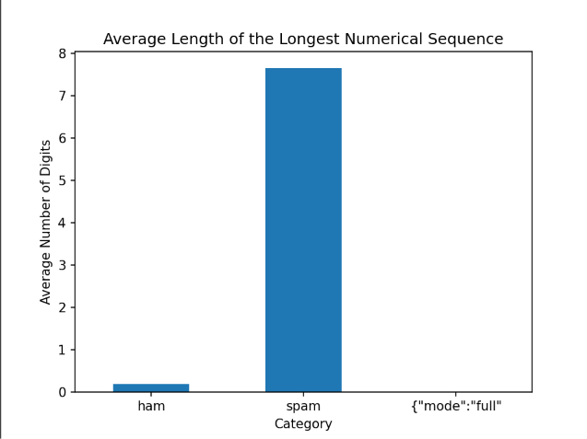
Figure 31 chart displaying the average length of the longest numerical sequence in both spam and ham emails
Symbol Analysis:
Spam emails rely on visual attention-grabbing techniques and symbols is one method they usually implement. Symbols often indicate promotions, urgency, or attempts to get users to click on links.

Do spam emails use promotional and attention-grabbing symbols more frequently than legitimate emails?
For the mini report I will focus on these four symbols: %,£,$ as these have a direct connection to attention-grabbing and spam behaviour.

First, I calculated the percentage count of the two email categories.
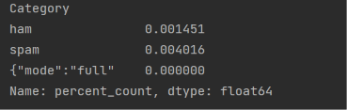
Figure 32 code output displaying average percent count

As you can see, spam emails tend to utilise percentages more than legitimate emails. This can be due to that within ham emails, it is normal conversations that can be informal and therefore tend not to need to include the percentage symbols. When it does include them, it is used in a way that does not seem predatory and consistent within spam behaviour. Whereas with spam emails, it is used to signify a promotion (price decrease) which correlates with spam behaviour.

Next I looked at the currency symbols ($, £, ):
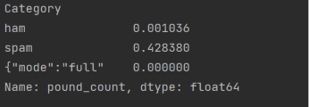
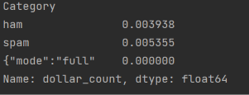
Figure 34 average amount of pound (sterling) symbols used within emails
Figure 33 average amount of dollar symbols used within emails

What we can see is that spam emails use the dollar and pound symbols than ham emails, mainly due to the symbols resembling a price of an item that is usually an attention-grabbing price, a price that does not seem real relative to the item being shown for it.

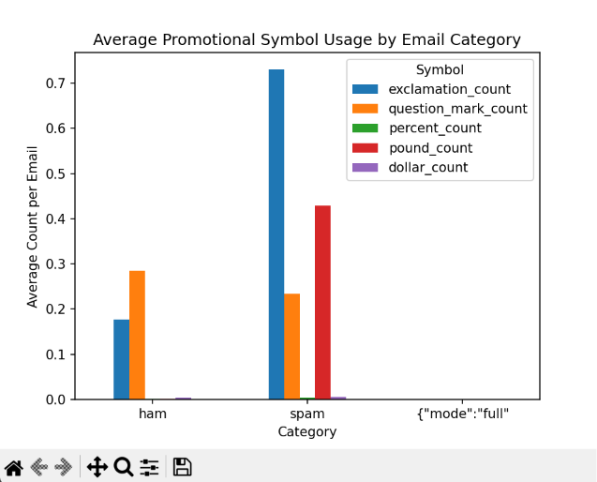
Figure 35 plot displaying average count for symbols in emails

The reason why this plot was made was to be able to see the comparison of symbols being used within spam and legitimate emails visually. What we can see from the chart is that exclamation points have the highest count overall, question marks has the highest for legitimate emails. Once again that can be the case because legitimate emails tend to consist of general conversations where the sender may be asking questions to the recipient. Whereas with spam emails it will be less prevalent. There is a correlation with exclamation points being a recurring feature and the statement that spam emails are created to grab the attention of users and be exaggerate in a way, so the use of exclamation points help reach that point out to users.
One thing that is surprising is the pound (£) symbol not being higher on the chart. The reason being is because that the most prevalent form of spam emails was prizes & giveaways (see figure 2) this could potentially be due to the volume of exclamation points being utilised as to increase the users attention span to these emails, multiple exclamation points would be used within a single email to manufacture the sense of urgency and surprise within the text contents of a spam email.
To conclude, to answer the question, yes spam emails do use promotional and attention-grabbing symbols to garner the attention of others. This is shown by a combination of currency symbols being used to show a price to the user that would be deemed unbelievable and a barging in fact, the exclamation points scattered within spam emails to create a sense of urgency, which overall persuades the user to click on the links of these emails. With legitimate emails, these symbols and numbers are less frequent.

URL/Links Analysis:
URLs have a clear connection to phishing & spam, and it also would translate into a useful machine learning feature for later on.

This part of the analysis is important as the primary objective of spam emails is to encourage the recipient to click on a link. These links may direct users to: phishing websites, fake login pages, fake shopping sites, promotional offers, and many more. Legitimate emails can also contain links, but they are generally less frequent and are often from trusted organisations.
By analysing URL usage, we can investigate whether the presence of links is a distinguishing characteristic of spam emails.
Do spam emails contain more URLs than legitimate emails?
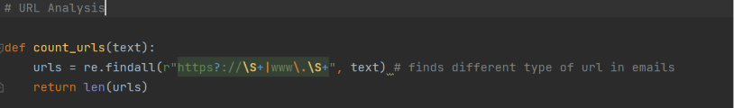
Figure 36 code to find different URL types in emails
What this code does is that it uses the regex module to be able to find specific text content within an email using re.findall(). First it find https text using https?. The question mark is added to mean that the s is optional. It then look for :// as that is an essential part of a link. Then I added \S+ which means to match every non-space character until a space appears, which means to combine https:// together alongside the potential site name as just one URL. For example: “http://wap. xxxmobilemovieclub.com?n=QJKGIGHJJGCBL” this is one of the spam emails that have this within the dataset.
Then the | symbol, which in python means the OR operator. What it does is that the text we are trying to find will either match the left side (https://) or the right side (www.) with the backslash after www indicating python to look for a dot (.) and then \S+ which combines the characters together until the next space. Last, it will count the amount of URLs with the return statement.

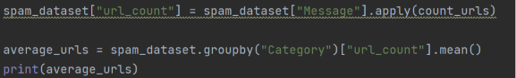
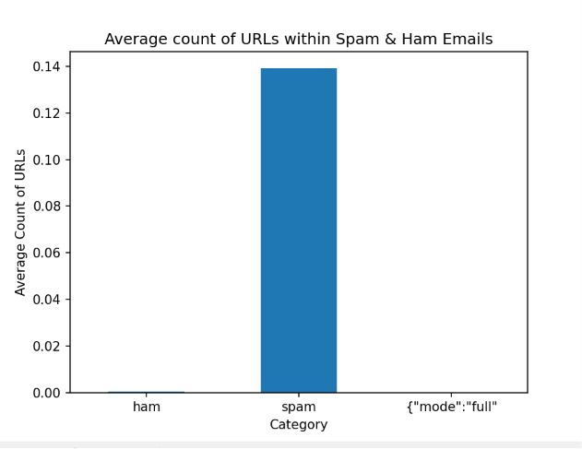
Figure 37 comparing the URL count between the two email categories

Figure 38 chart displaying average count of URLs within spam and ham emails
What these figures above tell us is that there are only an average of 0.000415 URLs within legitimate emails and an average of 0.14 in spam emails. This shows that URLs are more common within spam emails as they tend to include links for prizes and giveaways that can be used as phishing whereas with ham emails, links are less frequent and are usually from trusted people/organisations. As there was a significant difference between the two, URL count will serve as a useful predictive feature during machine learning model development.
To conclude and answer the question, yes URLs are more common in spam emails than legitimate emails with the evidence shown above.

Correlation Analysis:
This is one of the most important parts of the exploratory data analysis stage because we are now looking at how features relate and correlate with each other as opposed to looking at features individually. It also provides a natural bridge into the ML stage.
Correlation analysis measures the strength and direction of the relationship between two variables and datasets to see how strong that relationship may be. (James, 2021). The analysis conducted will be able to answer questions such as: Do longer emails usually contain more words?, Do emails with more numbers also tend to contain more symbols?, Do emails with more URLs also have more exclamation marks?.
The purpose of correlation analysis in this case is to identify relationships between the features extracted during EDA. After identifying and understanding these relationships will help determine which features provide unique information, which features are closely related, whether some features may be redundant or are likely to contribute useful information to the machine learning model.
What does correlation tell us?
Correlation values range from -1 to +1. +1 is a perfect positive correlation, so as one feature increases, the other always increase. 0 means no correlation which tells use the features being used have no obvious relationship. -1 stands for perfect negative correlation where one feature increases while the other decreases.
Why does this matter for machine learning?
Well feature engineering is about creating useful features to provide the best results and correlation analysis helps evaluate the feature set before training a model. A quick example:
Email Length ─────── 0.98 ─────── Word Count. This shows that these features contain very similar information. Understanding these relationships will help when explaining my design decisions for the model.
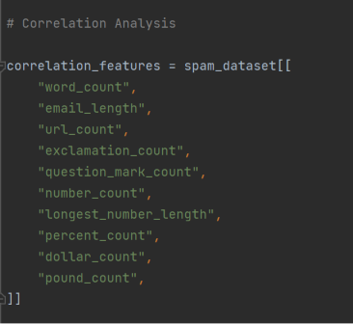
Figure 39 selecting features to be used in correlation matrix
Here It is just the selection process of the features going to be implemented in the correlation matrix. I chose the most appropriate features from the EDA.
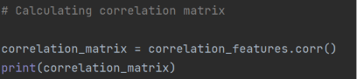
Figure 40 calculating correlation matrix
This is the code that calculates the correlation matrix. .corr() compares every feature with every other feature until every combination has been analysed.

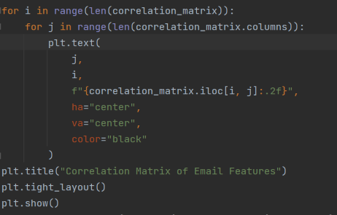
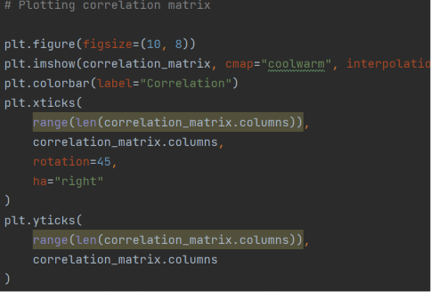
Figure 41 code displaying plotting the correlation matrix

This part of the code shows the plot of the correlation matrix. There was a simpler alternative however such solution wouldn’t of have included the correlation values inside the boxes.

What it does is first converts the correlation matrix into an image with plt.imshow() where it will turn every number within the correlation matrix into a coloured square. cmap chooses the colour scheme. Plt.colorbar() adds the colour scale. Plt.xticks & plt.yticks in this case adds labels to the x-axis and the same for the y-axis.
For the nested for loops, it visits every square in the matrix. In plt.text(), the purpose of it is to write the correlation value inside each coloured square. correlation_matrix.iloc retrieves the value in row I and column j and displays the value with 2 decimal places with :.2f. so for example 0.973850 becomes 0.97.

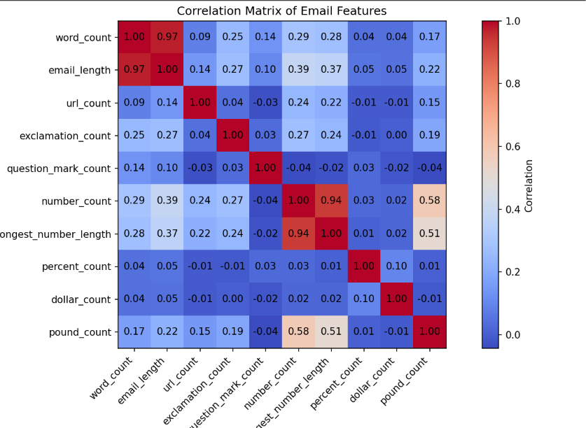
Figure 42 correlation matrix of email features

Correlation analysis summary:
Correlation analysis was performed to understand the relationships between the engineered email features and determine whether they provide unique information for spam classification.
The strongest correlation observed was between word count and email length:
Word Count ↔ Email Length: r = 0.97
This indicates a very strong positive relationship, meaning longer emails naturally contain more words. Since both features measure email size, they may provide similar information to the machine learning model. During feature selection, their impact can be tested by training models with and without one of these features.
The next strongest relationships were:
Number Count ↔ Pound Count: r = 0.58
Longest Number Length ↔ Pound Count: r = 0.51
These moderate correlations suggest that emails containing currency symbols often contain more numerical information, which supports the idea that spam emails may use financial incentives such as prizes, discounts, or money-related offers.
Other relationships were mostly weak. For example:
URL Count ↔ Word Count: r = 0.09
This shows that URL usage is mostly independent of email length, suggesting that URL count provides different information and may be a useful feature for classification.
The weakest correlation was:
Dollar Count ↔ Pound Count: r = -0.01
This indicates almost no relationship between the two features, likely because currency symbols appear infrequently in the dataset.
More key findings include that word count and email length contain similar information and may require feature selection. Numerical and currency-based features show a relationship, supporting their usefulness in detecting spam patterns. Most features have weak correlation, meaning that they capture different characteristics of emails.
The impact that this will have on the detector and the machine learning model is that the analysis suggests that most engineered features can be retained because they provide unique information. However, highly correlated features such as word count and email length should be tested during model development to determine whether removing one improves model efficiency or performance.
The next stage will involve preparing these features alongside text-based features for machine learning classification.

Machine Learning Model Phase:
This part of the project is where the goal changes from understanding the data through data analysis to applying the data to building a model that can accurately classify unseen emails. The step that I will conduct in the section will include:
- Data Preparation
- Feature Engineering
- Text Vectorisation (TD-IDF)
- Train/Test Split
- Model Training
- Model Evaluation
- Model Comparison
- Final Model Selection

Preparing the Dataset:
Before a machine learning model can be trained, the dataset must be separated into features (information used to make prediction) and the target variable which is the value that the model is trying to predict.
In this project, the feature is the emails, while the target variable is the email category.
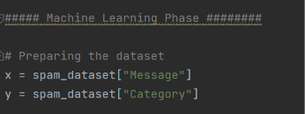
Figure 43 features and target variable code
X stores the independent variable, which contains the information the model will learn from
Y stores the dependent variable (label/email category), which tells the model whether each email is spam or legitimate
Next we have to encode the labels as machine learning algorithms cannot process text labels such as “spam” and “ham”. This means that the labels must be converted into numerical values
Converting Text into Numerical Features and Values:
Once again, machine learning model only work with numerical data. Therefore, the email test must be converted into numbers before training the model
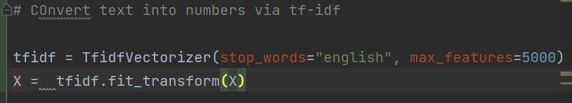
Figure 44 converting text contents of emails into numerical values
TF-IDF or Term Frequency-Inverse Document Frequency vectorizer transforms each email into a numerical representation based on the words it contains. Unlike a simple word count, TF-IDF assigns an importance level to all words so words that are distinctive across the dataset are assigned greater importance, whereas common words such as the, and, or is has its importance level reduced.

Splitting the Dataset:
The purpose of this is that by dividing the dataset into separate training and testing sets, it helps evaluate how well the model performs on previously unseen data.
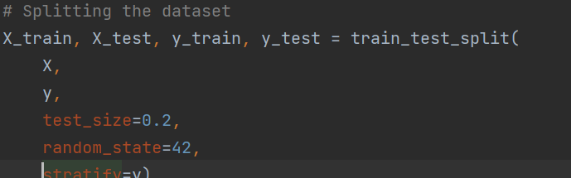
Figure 45 code displaying dataset being split into training and testing sets
The training set is used to teach the model the patterns that distinguish spam from legitimate emails. The testing set is withheld during the training process and is only used after the model has been trained. This provides a fair assessment of how well the model generalises to new emails. Test_size=0.2 allocates 80% of the data for training and 20% for testing.
Random_state=42 ensures that the same split is produced each time the code is run, again making sure that this process is fair and just. It also makes the experiment reproducible.
Stratify=y preserves the original proportion of spam and ham emails in the two datasets, which prevents one class from being overrepresented in either set.
This step is crucial to the model as without it, the model could simply memorise all of the training data, leading to misleading high performance.

Training the Machine Learning Model:
Now that the data has been prepared, the model can begin learning patterns that can distinguish spam from legitimate emails
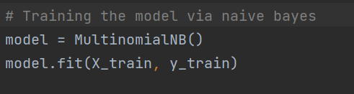
Figure 46 code for training ML model
Within this code, it is creating a Multinomial Naive Bayes classifier. This is a supervised machine learning algorithm based on Bayes’ theorem. It is used for discrete data like word counts or frequencies.
Next, with model.fit(X_train, y_train), it starts the learning process. This model analyses every training email and begins identifying which words are commonly associated with spam and which are commonly associated with ham emails. This will help the us learn how to find out what emails are spam easier.
Why Multinomial Naïve Bayes?
Multinomial Naïve Bayes is a good model to start with because it is simple to understand and explain, fast and light in terms of that it requires little memory and computer power, meaning that it runs well on large datasets. (Ide, Nolet, 2022). It is also great for text as it can fit data that shows counts & frequencies.
This makes it easy for Naïve Bayes classifier to link with a text classification tool like TF-IDF.
Generating Predictions for ML model:
After the training process, the model is used to classify emails that it has never seen before. Before doing so, generating predictions is a good way to see if results are accurate to the predictions that are made and that such model is efficient and accurate enough to be deployed into further development.
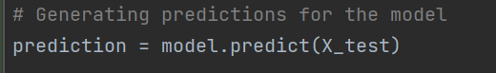
Figure 47 code displaying predictions being generated for the model
With this, each emails in the testing dataset is passed into the trained model. The model analyses the numerical features produced by TF-IDF and predicts whether each email belongs to the spam or ham category. These predictions being generated are then compared with the true labels to measure the model’s performance

Evaluating the Model:
Here is where the predictions must now be compared with the true labels to determine how well the model performed.
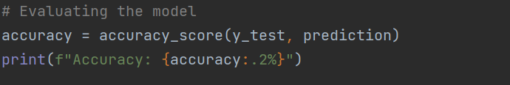
Figure 48 testing the accuracy of the model
When running the code for this, at first it did not work due to the code earlier on train_test_split (see figure 45)
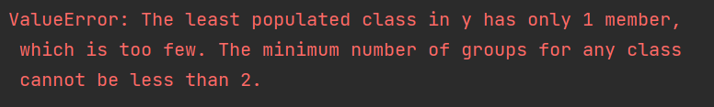
Figure 49 error code for train_test_split code
What this means is that the dataset contained an extra category “{“mode”:”full” with only 1 row. So after encoding the text, the labels became 0 = ham, 1 = spam, and 2 = “{“mode”:”full”. This affects the whole code because when we try to split every class into training and testing sets it cant because the third class only has one example, therefore it cannot be split.
“{“mode”:”full” was also a common feature throughout the plots that were made during this project but now it doesn’t enable me to continue on with my evaluation of the model.
To fix it I add this after loading the dataset right at the beginning of the file:
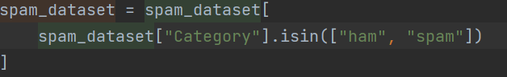
Figure 50 fixing code by removing mode:full
What this does is that it only keeps rows where the category is ham and spam and removes the other class.
Now when checking the accuracy of the model, it will work.
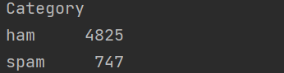
Figure 51 shows the two categories of email and not anything else
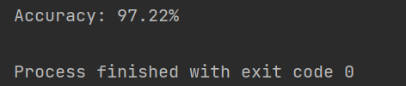
Figure 52 accuracy score of ML model
With the figure above, it shows that the predictions aligned with the tests had a 97.22% accuracy score. This shows that the model created is accurate, efficient, and correctly classified around 97 out of every 100 emails within the test set. It also is able to tell what emails are legitimate and spam but this doesn’t conclude the evaluation process as accuracy is only one form of metric.
Next was the implementation of a classification report.
A classification report is another metric in the form of a table that calculates several performance measures and sorts them into groups. (scikit-learn, 2018).
Precision, where of all the emails predicted as spam, how many were actually spam?
Recall, of all the spam emails, how many were did the model detect successfully?
F1-score, a balanced measuring tool that combines both precision & recall.
Support, the number of examples belonging to each class.

Figure 53 classification report code
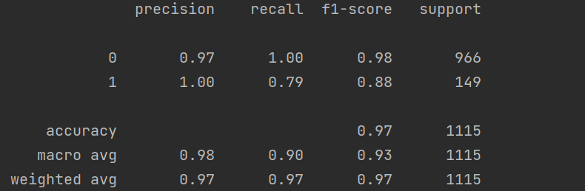
Figure 54 classification report output
These results are very useful to see because it shows metrics that the accuracy score would hide.
From what we can see 0 represents ham legitimate emails and 1 being spam emails.
What first can be gathered from the output is that the ham performance is excellent as the ham recall is 1.00 (100%). This means that the model successfully identified all 966 legitimate emails as ham. The ham precision of 0.97 means that when the model classified an email as ham, it was correct around 97% of the time.
The spam precision also had a perfect rating of 1.00. What this entails is that every email the model predicted as spam was actually spam in this test set. So the model was not incorrectly throwing legitimate emails into spam section often.
One weakness within the classification report however is the spam recall with only 79%. This shows that the machine learning model detected approximately 79% of the actual spam emails, but missed around 21%. The test set used contained 149 spam emails and 966 ham emails, so the model detected around 118 spam emails, while roughly 31 spam emails were incorrectly classified as ham. Those 31 emails incorrectly classified are known in this case as false negatives.
For a spam detector, this is important because these are spam emails that would get through the filter and in a real world scenario, this can lead to a user becoming a victim of a spam email which can lead to a phishing, scamming, and your information being taken.
This however concludes that the accuracy score of 97.22% is misleading. This is because the dataset was imbalanced in the beginning when loading the dataset and during this test where there are 966 ham emails and 149 spam emails. This shows that 87% of the test data is ham. The model can achieve a very high overall accuracy because there are many more ham emails and they had a recall of 100%. This is why relying on accuracy alone does not showcase the full picture.
To conclude, the Multinomial Naïve Bayes classifier achieved an overall accuracy of 97.22%. The model demonstrated particularly strong performance when identifying legitimate emails, achieving a recall of 1.00. Spam classification produced a precision of 1.00, indicating that emails classified as spam were correctly identified. However, spam recall was lower at 0.79, indicating that approximately 21% of spam emails were incorrectly classified as legitimate. This highlights a limitation of relying solely on accuracy, particularly given the imbalance between the ham and spam classes.
This raises a new question now which is can alternative machine learning algorithms improve the detection of spam emails while maintaining high precision and reducing false negatives leading to a more reliable and accurate spam detector?
To answer this question the following Machine Learning algorithms will be used for training:
Logistic Regression, SVM, and Random Forest. The same train/test data will be used and same metrics will be compared as well.

Logistic Regression:
First we are going to test the accuracy and efficiency of the data using logistic regression.
Logistic Regression is a supervised machine learning algorithm used to predict the probability using binary output (0/1). (Lee, 2025). Logistic Regression is mainly used for classification problems and will learn patterns in the TF-IDF features that will help distinguish spam from ham.
Figure 55 importing Logistic Regression into the file
Here the Logistic Regression algorithm is being imported from the scikit-learn library.

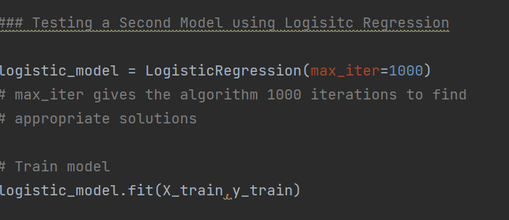
Figure 56 code creating and testing logistic regression model
Within this block of code here, it involves the creation of the logistic regression model and training the model. The training part is where the model learns from the prior training data so X_train revolves around email information and y_train includes the correct spam/ham labels. It looks for relationships between the words in the email and their categories. This is the same X & y train that was used for the Naïve Bayes model as it makes the comparison fair.
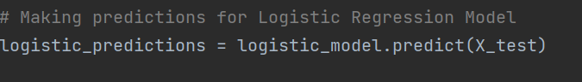
Figure 57 predictions being made for logistic regression model
Next, it’s the stage where predictions are being created for the Logistic Regression model.
What this does is that the trained logistic regression model receives unseen testing emails and then churn out predictions with them only being 0 for ham and 1 for spam.

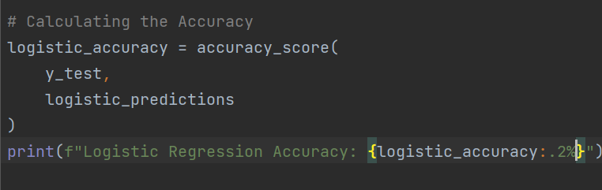
Figure 67 Calculating the accuracy of the model
Like with the Naïve Bayes model, it compares the actual answers from y_test with the models answers from the predictions and calculates how many were correct.
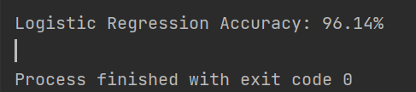
Figure 68 Logistic Regression Accuracy result
As we can see, the accuracy of the logistic regression model (96.14%) is less than the accuracy score of the Naïve Bayes model with 97.22%.
However, this is not the complete picture as the Naïve Bayes model had a glaring weakness within the classification report: its spam recall was only 79%. So Logistic Regression may have a lower overall accuracy but may potentially detect more spam.

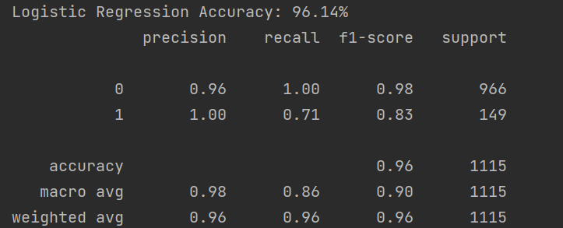
Figure 69 Logistic Regression classification report
From an overall standpoint, it seems that the average score and accuracy for Logistic Regression is lower than Naïve Bayes.
When analysing the report we can see that the spam precision stayed at 100%, which mean that when either model predicted an email as spam, it was correct. Another piece of data that stands out is that the spam recall became worse. This is the biggest difference as for Naïve Bayes the spam recall was 0.79% whereas with Logistic Regression, it was 0.71%. So Logistic Regression detected a smaller proportion of the actual spam emails. With 149 spam emails in the test set, a 0.71 recall means it detected around 106 spam emails, leaving 43 incorrectly classified as ham. Meanwhile with Naïve Bayes, it detected 118 spam emails so 31 were missed.
To Conclude, this indicates that Logistic Regression failed to identify a greater proportion of the spam emails when compared to Naïve Bayes, meaning that Multinomial Naïve Bayes was the stronger model of the two for this specific dataset.
Support Vector Machine (SVM):
The next algorithm that will be looked at for training is the Support Vector Machine, or better known as SVM.
SVM is a supervised machine learning algorithm, so it is uses labelled data to predict known outcomes, which in this case is accuracy of spam and ham detection. SVM is used for classification, regression, and outlier detection. (scikit-learn, 2018). Various advantages that it posses includes being effective in cases where the number of dimensions is greater than the number of samples.
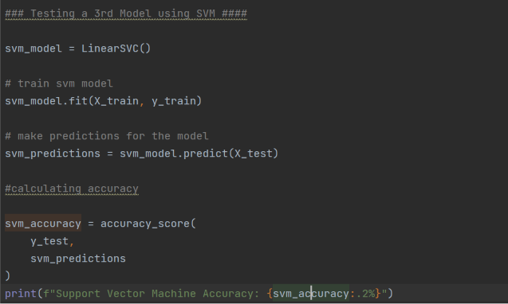
Figure 70 SVM model code
Here is the code that is used when creating the svm model, it is identical to how the code is constructed on the other models that were implemented. The library and module that was used to help was again scikit learn.
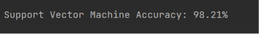
Figure 71 SVM accuracy score
When we run the code and get the output, the SVM model has an accuracy score of 98.21%, which is actually more than both the Naïve Bayes and Logistic Regression models.
In terms of reasons why this can be the case, well one is that SVM is very compatible with TF-IDF where the emails have been converted into thousands of pieces of data. SVM is also effective at finding a boundary between different classes when there are many features, which is common in text classification. Another big reason why this could be the case is that SVM in a way focuses on the complex examples of data. SVM focuses heavily on the observations closest to the decision boundary, known as support vectors and these observations (in this case difficult emails) near the boundary have a greater influence on the final classifier. This characteristic of SVM the model distinguish between spam and ham emails and especially those that have similar wording and structure.

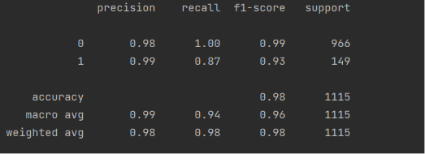
Figure 73 SVM classification report
What can be gathered from the SVM classification report is that it is a significant improvement on the previous two models. What makes this result better than its predecessors is the spam recall. For SVM, it had a spam recall of 0.87 (87%) compared to Naïve Bayes with 0.79 and Logistic regression with 71%. This means that SVM is detecting approximately 87% of the actual spam emails.
The precision score of SVM is also very high with 0.99 which is only a 0.1 decrease from the other models. This shows that by using SVM it has a good balance of both high precision plus high recall which ultimately ends up with a high f1-score. The high f1-score is reflected in the report with it being 0.93 which is considerably better than Naïve Bayes with 0.88 and Logistic regression with 0.83.
To conclude, the support vector machine produced the strongest performance among the three evaluated classifiers, with an accuracy of 98.21% and more importantly achieving a spam recall of 0.87 and an f1 score of 0.93. The improvement in recall indicates that the SVM was able to identify a greater proportion of actual spam emails while maintaining a high spam precision of 0.99 when compared to other models.

Further Analysis within the three models:
In terms of what would be used to analyse these models further, it will be a confusion matrix. This is being used because the classification reports tell us how well each model performed, while the confusion matrices shows us where the model made their mistakes.

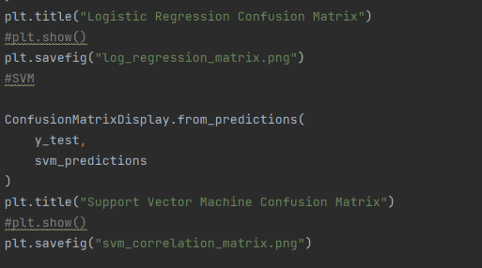
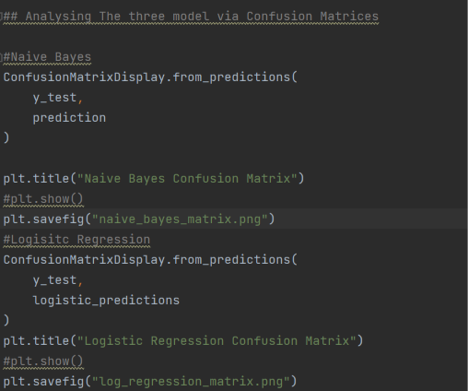
Figure 74 confusion matrix code for all three models

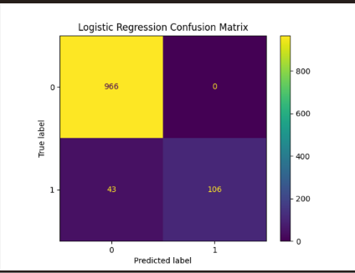
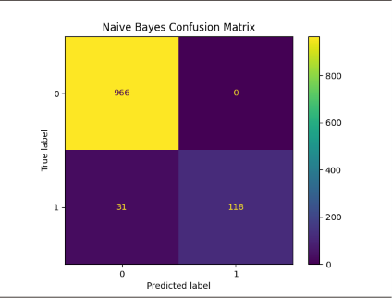
Figure 76 Logistic Regression confusion matrix
Figure 75 Naive Bayes confusion matrix

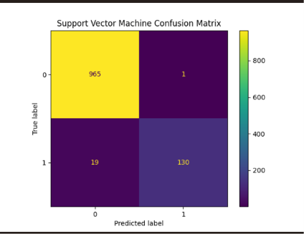
Figure 77 SVM confusion matrix

The use of confusion matrices were implemented here to investigate the types of classification errors that were produced by each model.

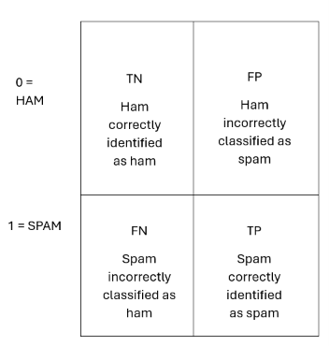
This table created explains what the numbers within the boxes of the confusion matrices mean and stands for.
One particular piece that is important at this current stage are False Negatives.
With the first model Naïve Bayes, there were 118 emails correctly identified as spam and 31 that were spam incorrectly identified as ham (legitimate emails). This explains why the recall shown earlier in the classification report was 79%.
For Logistic Regression, there we 106 spam emails correctly identified as spam and 43 that were incorrectly classified as ham therefore, it produced 43 false negatives which is worse than Naïve Bayes as it means this particular model had a spam recall percentage of 71.
With the third and final model that was trained (SVM), there were 130 spam emails correctly identified and 19 that were incorrectly classified as legitimate emails. This means that SVM had 19 false negatives and compared with the other models, it clearly showcases how SVM is currently the best and strongest model in terms of accuracy and efficiency.

Can the performance of the SVM model be improved?
It has been established that Support Vector Machines was the best model used in terms of accuracy and overall performance with an accuracy of 98.21% and a spam recall of 0.87. However, if the spam email detector is going to be a reliable tool for detecting and differentiating spam and legitimate emails, the model has to been tuned to the limit performance wise.
One way that can be investigated to see whether changing the model’s settings can improve the performance is Hyperparameter Tuning.
Hyperparameter tuning is the process of selecting the most optimised configuration settings, which are better known as hyperparameters before training a machine learning model, in order to improve accuracy and performance on unseen data. (Belcic and Stryker, 2024).
In this case, a hyperparameter is a setting that will be chose before training the model. For the SVM model, an important hyperparameter is c and the default model that was used was svm_model = LinearSVC().
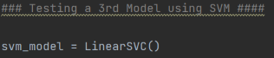
Figure 78 default svm model
C controls how strong SVM tries to avoid incorrectly classifying training examples and there are different levels of this hyperparameter. A low C allows more training errors but its decision boundary is more simple and less complex, a high C penalises more training errors and tries harder to attempt to correctly classify the emails from the training data
What will commence is the different values of “c” will be tested to see which one produces the best results.
The different values of C will include:
C = 0.01
C = 0.1
C = 1
C = 10
C = 100.
The original SVM (default model) effectively used C = 1.

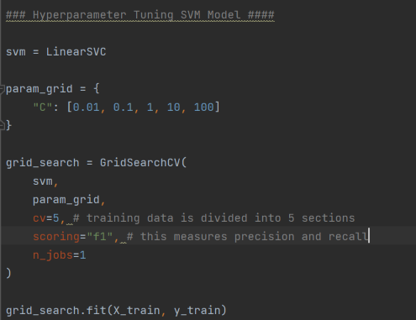
Figure 79 Hyperparameter tuning code
So within this code, its tests the five Cs mentioned earlier and then the scores from each are averaged, which gives a more reliable estimate of how each C value performs. GridSearchCV is a scikit-learn function that is used to perform hyperparameter tuning by training and evaluating a machine learning model using different combinations of hyperparameters. (Verma, 2023).

Figure 80 printing the best C value and best F1 score

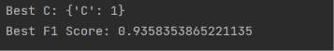
Figure 81 Best C and F1 score output
From the grid search where it tested the C values, it result in C = 1 producing the best average F1 score with approximately 93.58%. This is a very interesting result because the original SVM model used the default C value with 1.
In terms of what can be gathered from this, the tuning did not discover a better C value and essentially confirmed that the default C was already the best among the values.
This is not the end result however as this score that was just obtained was only using the training data (X_train, y_train) and not the test data. So with this result it will be used on another function of GridSearchCV which is best_estimator and implement it on X_test to see if hyperparameter tuning has improved the original svm model accuracy.
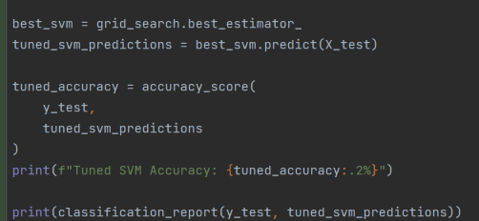
Figure 82 evaluating tuned model on test data
Again, this is being done because GridSearchCV has only used the training data of the spam and ham emails.

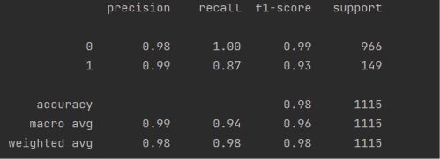
Figure 83 tuned model results

Hyperparameter tuning was performed on the SVM classifier to investigate whether adjusting the C parameter could improve classification performance. Values of 0.01, 0.1, 1, 10, and 100 were evaluated using five-fold cross validation, with F1 score used as the optimisation metric to measure precision, recall and due to the imbalance between the amount of spam and ham emails with ham having more emails than spam. The most optimal configuration was found to be C=1, providing an F1 score of 0.936. this was the default value used by the initial SVM model, when evaluated against the unseen test dataset, the tuned model achieved an accuracy of 98.21% , with a spam recall of 0.87, and an F1 score of 0.93. These results were the same as the SVM model that was trained and configured earlier.
Therefore hyperparameter tuning of C did not provide an improvement this time, suggesting that the default SVM configuration was already well suited to the dataset.

Testing the SVM model on manually made new emails:
Next, the SVM model will be tested on emails that were not originally on the Kaggle dataset to see whether the model can generalise and detect spam activity or legitimate activity on realistic, and unseen messages.

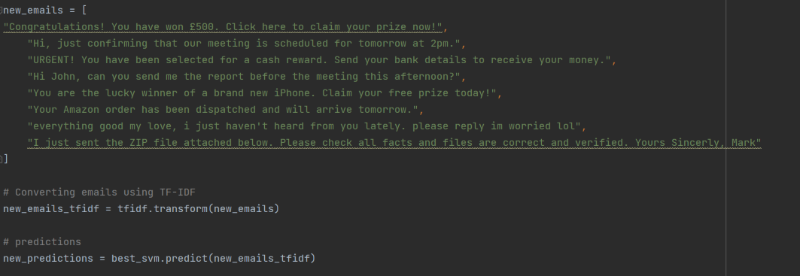
Figure 84 new emails created plus converting emails and predictions
Within this figure above, it displays the emails I created to test whether the model functions on unseen emails.
What was also implemented was the code that converts emails via TF-IDF. Instead of earlier in the project where fit_transform() was used to learn the vocabulary from the original dataset (X = tfidf.fit_transform(x). so it learned words such as free, winner, claim etc... thar are all predominantly included within the text content of a spam email. So the new emails need to be converted using the same vocabulary therefore, the code means to take these new emails and represent them using the vocabulary and TF-IDF rules that were already learned.
Below that line of code, is the predictions for new emails being made using the best SVM model.
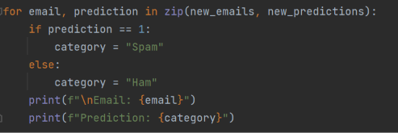
Figure 85 for loop that will label whether a email is spam or ham using svm model

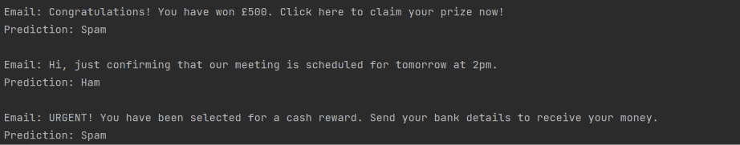
Figure 86 code output
The output shows that every email that was originally predicted as spam or ham was correctly classified. This does not mean that the model has 100% accuracy however as eight emails is to small of a sample to make such a claim, which is why for now it is just a small external test.
To Summarise this section; to further assess the generalisation of the final SVM model, a small external test was conducted using eight manually created email messages that were not included in either the training or testing datasets. The emails represented a mixture of spam and legitimate communication, including promotional messages, meeting arrangements, personal communication and work-related messages. The model correctly classified all eight messages, resulting in 100% accuracy for this small test. Although the sample size is too small to draw statistically significant conclusions, the results provide an initial indication that the model can generalise to previously unseen email content.

Bigger Sample Test:
30 emails were made and added to make it a fairer test and to see if this model is still accurate and efficient when dealing with a larger amount of unseen emails.
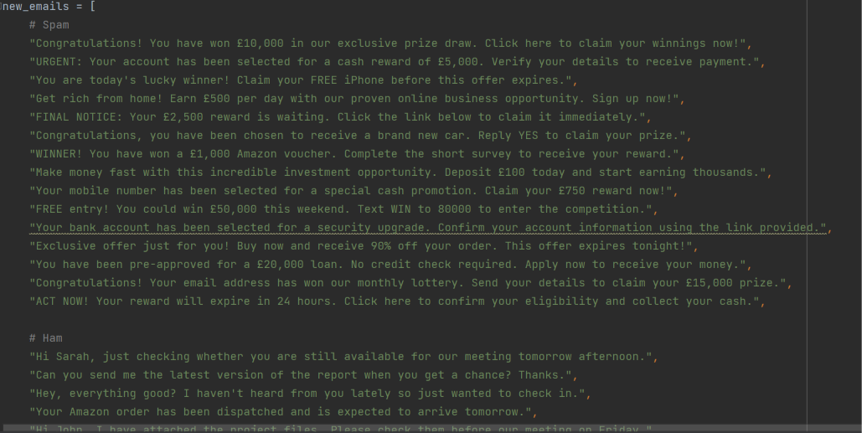
Figure 87 15 spam and 15 ham emails were added

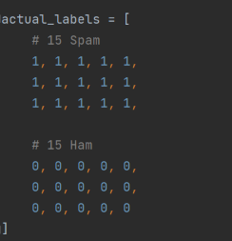
Figure 88 labels that show which emails are spam and ham before testing to see if predicted results are the same

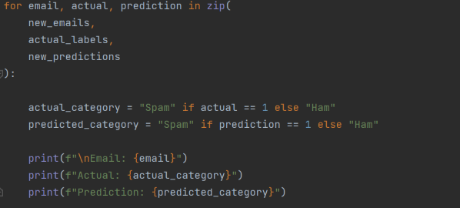
Figure 89 code that displays the actual category and predicted if it is spam or ham
With this code it actually shows the actual category under the predicted category to give a better visualisation if the prediction was correct.
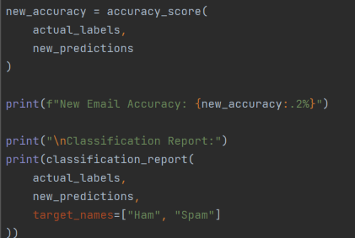
Figure 90 accuracy score check and classification report

Out of the 30 emails made, 4 were incorrect giving it a 86.67% accuracy score.
The 4 emails that were incorrectly predicted:
Figure 91 incorrect email 1
Although this is clearly spam to a human, it may contain words that also appear in legitimate emails within the training data.

Figure 92 Incorrect email 2
This is another example of financial/investment spam that may not have enough distinctive vocabulary for the model to confidently classify it as spam.
Figure 93 Incorrect email 3
This email has common phishing, scam vocabulary patterns so the fact is was distinguished as ham is surprising.
Figure 94 Incorrect email 4

This can be seen as a limitation when compared with the original test result.
The original test result was 98.21% whereas with this external test, it has an accuracy of 86.67%.
What can be interpreted from this is that the model performs well when classifying emails that follow the patterns found in the Kaggle dataset, but its performance decreases when presented with manually created emails containing different vocabulary and phrasing. However, when presented with more data more emails the same amount as the original test data, the accuracy can increase.
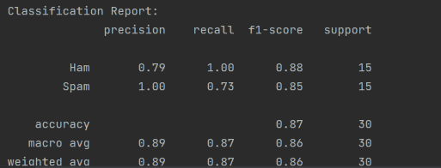
Figure 95 classification report for created emails
With the spam recall in the original SVM, it was 0.87. In the external test, it is only 0.73 a 0.14 decrease. This is important because this is a spam detector project so false negatives is key. The positives of the classification report is the spam precision as it had a perfect score of 1.00, which means that every email the model classified as spam was actually spam plus the ham recall was also 1.00.
The final SVM classifier was additionally evaluated using 30 manually created emails that were completely independent from the original dataset. The model achieved an accuracy of 86.67%, which was lower than the 98.21% achieved on the original test set. Spam recall also decreased from 0.87 to 0.73. Four spam emails were incorrectly classified as legitimate, while no legitimate emails were incorrectly classified as spam. This suggests that although the classifier performs strongly on data following the patterns present within the original dataset, its performance decreases when exposed to different wording and potentially unseen patterns. The results highlight a limitation of relying on a single dataset and demonstrate the importance of evaluating machine-learning models on independent data.

Comparing my Spam Detector Model with Existing Research:
With this, it is to find out how this current approach compare with other Machine Learning approaches to spam detection, and why might the results differ.
Paper 1: Enhancing Spam Email Detection with Machine Learning: A Comparative Study of Logistic Regression and Naïve Bayes Using Apache Spark by Zhaoyang Ye (November 2024).
https://www.researchgate.net/publication/387716584_Enhancing_Spam_Email_Detection_with_Machine_Learning_A_Comparative_Study_of_Logistic_Regression_and_Naive_Bayes_Using_Apache_Spark
Citation and Abstract of this paper:
Ye, Zhaoyang. (2024). Enhancing Spam Email Detection with Machine Learning: A Comparative Study of Logistic Regression and Naive Bayes Using Apache Spark. Transactions on Computer Science and Intelligent Systems Research. 7. 78-85. 10.62051/gt8zn492.
The spread of spam emails presents serious problems for both email security and user experience. This research aims to develop an effective spam email classification system utilizing machine learning techniques, specifically Logistic Regression and Naive Bayes, within the Apache Spark framework. The methodology encompasses a thorough preprocessing of the Enron email dataset. This process involves several critical steps: text cleaning to remove irrelevant information, tokenization to break down the text into individual words, removal of stop words to eliminate common but uninformative words, and text feature extraction using Term Frequency-Inverse Document Frequency (TF-IDF) to quantify the importance of terms within the dataset. The study is conducted on a subset of the Enron email dataset, comprising 11,029 emails, with 2,996 labeled as spam. Experimental results demonstrate that the Naive Bayes model outperforms Logistic Regression, achieving higher accuracy and F1 score. This finding underscores the robustness of Naive Bayes in spam email classification, highlighting its potential for enhancing email security by effectively filtering spam.
Comparison of Paper 1:
With this paper, it is useful as it directly compares two of the same models I have already tested with that being Logistic Regression and Naïve Bayes, and it also uses TF-IDF. The only downside is that is does not utilise SVM however, the next paper that will be featured does use such classifier.
In terms of their methodology compared with the models used in this paper, Ye used an Enron subset as their choice of dataset with a size of 11,029 emails with 2,996 of them being spam. Compared with this one, it used a Kaggle Spam Email dataset with 5,572 emails with 747 of them being classed as spam. In terms of text processing, Ye used Lowercase, punctuation removal, stop words and tokenisation. For their choice of feature extraction, it used TF-IDF. When compared with the latter, for text processing, the processing method choice was TF-IDF-based preprocessing and for feature extraction, TF-IDF was used as well. For the evaluation process there are similarities as for both papers, it used Accuracy, Precision, Recall, F1 however, the main differences is that for the former (Ye). Another method that was used for evaluation was ROC/AUC.
To summarise, the important similarity that makes a comparison fair is that both studies implement TF-IDF and directly compare Logistic Regression with Naïve Bayes.
The following figure is the results of Ye’s model:
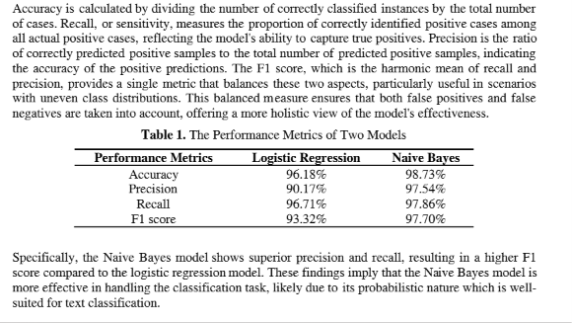
Figure 96 performance metrics of Ye's Studies
Their conclusion was that Naïve Bayes outperformed Logistic Regression across the reported metrics.
When compared to the results of this studies’ performance of the models:
Model | This Study | Ye’s Paper
Logistic Regression | 96.14% | 96.18%
Naïve Bayes | 97.22% | 98.73%
SVM | 98.21% | N/A

What we can gather from this table is that the Logistic Regression result identical, which is a strong point for this study as despite using different datasets and implementation, the Logistic Regression accuracy was remarkably similar. The Logistic Regression model with the accuracy of 96.14% and the 96.18% reported by Ye (2024). Also provides supporting evidence for the effectiveness of Logistic Regression in TF-IDF-based spam classification.
In terms of chiming in on the accuracy, precision, recall, and F1 for Naïve Bayes, the Naïve Bayes model used here recorded an accuracy of 97.22%, a spam precision of 1.00, a spam recall of 0.79, and a spam F1 of 0.88. The results of Naïve Bayes reported by Ye (2024) had an accuracy of 98.73%, a precision of 97.54%, a recall of 97.86%, and an F1 score of 97.70%.
The Naïve Bayes model in Ye’s study achieved higher overall performance than the Naïve bayes model developed in this project. However, direct comparison should be interpreted cautiously because the studies used different datasets and preprocessing approaches. Dataset characteristics, class distributions, and evaluation procedures can substantially influence classification performance.
One other thing that can be pointed out from both studies is that it reached the same verdict in terms of that Naïve Bayes outperformed Logistic Regression for spam classification using TF-IDF-based features.
With Ye’s study, it only utilised two classifiers with Naïve Bayes and Logistic Regression whereas with this one it added a third with SVM. SVM was also the best model performance wise when it came to comparing the three models.
Here are the finding when comparing SVM to the best performing model in Ye’s paper with it being Naïve Bayes:
Metric | SVM | Naïve Bayes (Ye)
Accuracy | 98.21% | 98.73%
Spam Precision | 0.99 | 0.9754
Spam Recall | 0.87 | 0.9786
Spam F1 | 0.93 | 0.9770

When it comes to overall accuracy, Ye (2024) had a better accuracy with a difference only being 0.52% with 98.73. In terms of precision SVM had the better result with 0.99. when it came to recall and F1 score, Naïve Bayes recorded a better result with 97.86% and 97.70% respectively.
Once again, this does not completely mean that Naïve Bayes is the superior model as different parameters were used for the model.
To summarise, Ye (2024) compared Logistic Regression and Naive Bayes for TF-IDF-based spam email classification and found that Naive Bayes achieved superior performance. A similar pattern was observed in this project, where Naive Bayes achieved 97.22% accuracy compared with 96.14% for Logistic Regression. However, this project extended the comparison by evaluating a Support Vector Machine, which achieved the highest accuracy of 98.21%. Furthermore, an independent evaluation using manually created emails was conducted to investigate generalisation beyond the original dataset.

Paper 2: Meta-learner-based frameworks for interpretable email spam detection. Kshirsagar M, Rathi V and Ryan C (2025).
https://www.frontiersin.org/journals/artificial-intelligence/articles/10.3389/frai.2025.1569804/full?utm_source=chatgpt.com
Citation and Abstract of this paper:
Kshirsagar M, Rathi V and Ryan C (2025) Meta-learner-based frameworks for interpretable email spam detection. Front. Artif. Intell. 8:1569804. doi: 10.3389/frai.2025.1569804
Abstract
Introduction:
With the increasing reliance on digital communication, email has become an essential tool for personal and professional correspondence. However, despite its numerous benefits, digital communication faces significant challenges, particularly the prevalence of spam emails. Effective spam email classification systems are crucial to mitigate these issues by automatically identifying and filtering out unwanted messages, enhancing the efficiency of email communication.
Methods:
We compare five traditional machine-learning and five deep-learning spam classifiers against a novel meta-learner, evaluating how different word embeddings, vectorization schemes, and model architectures affect performance on the Enron-Spam and TREC 2007 datasets. The primary aim is to show how the meta-learner's combined predictions stack up against individual ML and DL approaches.
Results:
Our meta-learner outperforms all state-of-the-art models, achieving an accuracy of 0.9905 and an AUC score of 0.9991 on a hybrid dataset that combines Enron-Spam and TREC 2007. To the best of our knowledge, our model also surpasses the only other meta-learning-based spam detection model reported in recent literature, with higher accuracy, better generalization from a significantly larger dataset, and lower computational complexity. We also evaluated our meta-learner in a zero-shot setting on an unseen real-world dataset, achieving a spam sensitivity rate of 0.8970 and an AUC score of 0.7605.
Discussion:
These results demonstrate that meta-learning can yield more robust, bias-resistant spam filters suited for real-world deployment. By combining complementary model strengths, the meta-learner also offers improved resilience against evolving spam tactics. Kshirsagar M, Rathi V and Ryan C (2025)
With this paper, it uses Support Vector Machine with TF-IDF alongside XGBoost, Random Forest, Logistic Regression, and Naïve Bayes. It was also tested with bag of words and TF-IDF . SVM will be the only model that will be looked at as it is the best performing model within this study. It uses the TREC 2007 email dataset. The relevant results within their study with SVM are reported below:
Model | Features | Accuracy | Precision | Recall | F1
SVM | Bag of words | 97.53% | 97.60% | 98.67% | 98.13%
SVM | TF-IDF | 99.11% | 99.06% | 99.60% | 99.33%

This paper found that SVM with TF-IDF was the best performing traditional machine-learning pipeline on their experiment.
When compared to this variant of SVM being used, when it comes to accuracy this study had an accuracy of 98.21% whereas with Kshirsagar M, Rathi V and Ryan C’s study, they recorded an accuracy of 99.11%. when it cam to precision, there is only a 0.06 difference with their study having a precision of 99.06% compared with 99% in this study. With recall and F1 their recall had a score of 99.60% and an F1 of 99.33%. compared with this study, it recorded a recall of 87% and an f1 score of 93% respectively.
The difference between the two are not that stark. The accuracy within this study is only about 0.9 percentage points lower so this SVM classifier is performing very competitively when comparing the two studies based on the numbers. However, having a spam recall of 87% is noticeably lower than their reported recall.
In terms of why their SVM performs well, TF-IDF is a big reason why as TF-IDF converts each email into numerical features based on how important particular words are. For example, words that occur frequently across almost every email aren't particularly useful. However, words that are relatively distinctive can receive higher TF-IDF values.
Their paper explains that TF-IDF helps the model focus on discriminative terms rather than treating every word equally. That's important because spam emails often contain distinctive vocabulary. For example:
Congratulations, winner, prize, click, offer, cash, account, urgent
The exact words aren't necessarily enough by themselves, but TF-IDF gives the classifier useful numerical representations of the email.
Another reason why SVM worked well within detecting spam emails is the text features used. With this study SVM is working with 5000 text features, which SVM is well suited to as it is a variant of a high dimensional classification problem. With their paper, it explains that a linear SVM attempts to find a decision boundary that separates the two classes as much as possible while maximising the margin between spam and ham emails.
While TF-IDF is a big factor as to why the model performed as well as it did, there were several contributing factors such as the preprocessing process, the characteristics of the TREC 2007 dataset, dataset size and composition, class distribution, and their overall setup. This shows that it cant be simplified as to their method and model is better than this one as once again, different parameters are being implemented.
Another similarity that occurred between both papers is that external testing when using emails not involved within the dataset can affect the accuracy and overall performance of the model. When testing the accuracy of this model using new created emails, the model went from 98.21% on the Kaggle test set to 86.67% on the external emails. The spam recall dropped from 87% to 73% as well. With Paper 2 Kshirsagar M, Rathi V and Ryan C (2025). When testing the model on a different dataset, a hybrid dataset combining Enron-Spam and TREC 2007, the accuracy also dropped to 97.73%. This shows that performance can change when the distribution of the data changes.
To summarise Paper 2, Kshirsagar, Rathi and Ryan (2025) investigated different machine learning and deep learning approaches for email spam detection. The study evaluated models including Logistic Regression, Naive Bayes, Random Forest, XGBoost and Support Vector Machine (SVM), using both Bag of Words and TF-IDF representations. The study used the TREC 2007 and Enron-Spam datasets, as well as a combined dataset, to evaluate how well the different approaches performed.
One of the most relevant findings for this project was the performance of SVM using TF-IDF. On the TREC 2007 dataset, SVM with TF-IDF achieved an accuracy of 99.11%, precision of 99.06%, recall of 99.60% and an F1 score of 99.33%. This was stronger than SVM using Bag of Words, which achieved an accuracy of 97.53%. The results therefore suggest that TF-IDF provided a useful representation for the SVM model when classifying spam emails.
The study also showed that model performance could change depending on the dataset being used. SVM with TF-IDF achieved lower performance when evaluated on the combined dataset compared with TREC 2007. This demonstrates the importance of considering the data used to train and evaluate a spam detection model, rather than assuming that a high accuracy on one dataset will automatically translate to other email data.
Overall, the paper demonstrates that SVM combined with TF-IDF can be highly effective for spam email classification. It is particularly relevant to this project because the same general approach was used in this study, allowing the performance of the SVM model developed in this project to be compared with results from previous research.
The purpose of comparing the results with previous research is therefore not simply to show that the model achieved a higher or lower accuracy. Instead, it helps determine whether the findings of this project are consistent with existing research and provides context for interpreting the results. The comparison also helps identify areas where this project contributes additional analysis. In particular, this project compared three different classifiers, performed hyperparameter tuning on the SVM and tested the final model on 30 independently created emails. While the SVM achieved 98.21% accuracy on the original test set, its accuracy decreased to 86.67% on the external emails. This demonstrates the importance of evaluating how well a model generalises beyond the dataset on which it was trained and tested.
Therefore, the literature comparison supports the findings of this project while also highlighting an important limitation of relying solely on performance metrics from a single dataset. The previous studies demonstrate that TF-IDF combined with traditional machine learning models can achieve high performance, while the external testing in this project provides further evidence that strong performance on a particular dataset does not necessarily guarantee the same level of performance on new email data.

Creating the Spam Detector Application:
Next, it was time to create the backend and frontend of the spam email detector.
For the backend, the choice was Flask due to the familiarity and ease of access it presented it self as.
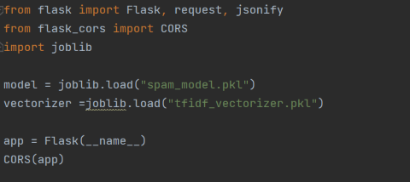
Figure 97 importing flask module, and Json

With the figure above, it shows various modules such as Flask and Json being imported in order to code the logic for the backend. Joblib is another module being imported to the app.py file as it is used to load the SVM model and training data that was used in the spam_analysis.py file, where all the work was done to find that SVM was the most optimal model and more.
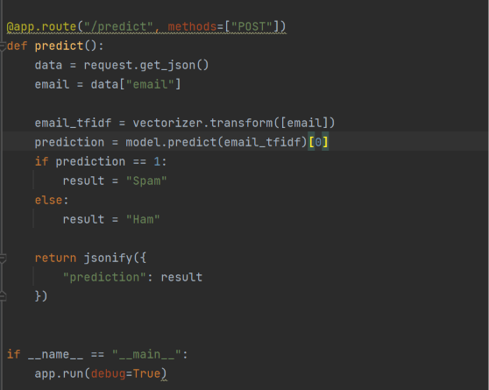
Figure 98 predict function to see if email is ham or spam
This block of code here in functioned to take an email that the user inputted and will send back a response which consists of Ham or Spam. With data = request.get_json(), this gets the JSON data that the user sends to the API; in this case the data is the email text contents. With the next line within the code, it involves converting the email using the TF-IDF vectorizer that was used during the training of models. After a prediction is made with [0] meaning that predict returns an array. Next is using an if loop to see if the prediction is spam or legitimate, if the prediction equals o 1, the result is spam, if it is not, it will return Ham.

